Multiple choice section

Question 1 [8.2]

An angle of size 210° is called:

A reflex B obtuse C acute D straight

Question 2 [8.7]

Which of the following statements concerning quadrilaterals is true?

A A square is not a type of rhombus.

B Diagonally opposite angles in a parallelogram are unequal.

C The two interior opposite angles of a kite where unequal sides meet are never equal.

D None of the above are true.

Question 3 [8.4]

This symbol ⊥ means that the two lines

A are parallel B are perpendicular

C are equal in length D form a straight angle

Question 4 [8.3]

Three angles make a revolution. The angles are 26°, 182° and x. The value of x is:

A 26° B 178° C 152° D 182°

Question 5 [8.7]

The quadrilateral shown is:

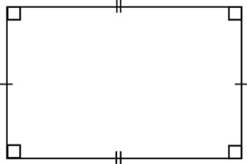

A a rectangle B a kite C a rhombus D All of the above

Question 6 [8.4]

The symbol || represents:

A parallel lines B perpendicular lines

C lines of equal lengths D a marked angle

Question 7 [8.5]

A polygon with 9 sides is called a:

A octagon B nonagon C decagon D undecagon

Question 8 [8.6]

The diagram shows a triangle that is:

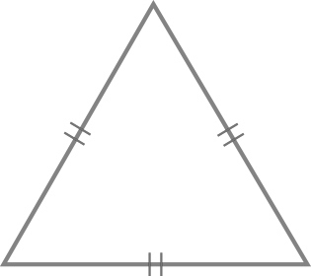

A scalene B acute-angled C equilateral D Both B and C

Question 9 [8.3]

The size of angle x is:

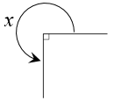

A 90° B 270° C 250° D 175°

Question 10 [8.3]

Angles x and y are vertically opposite angles. If y = 127°, x is equal to:

A 37° B 53° C 127° D 180°

Multiple-choice total marks: ____ / 10

Short answer section

Question 11 2 marks [8.2]

Describe the term complamentary angles. Use an example to help you explain.

Question 12 2 marks [8.1]

Use a protractor to measure the size of the following angles, correct to the nearest degree.

(a) 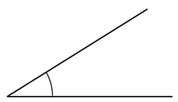 (b) 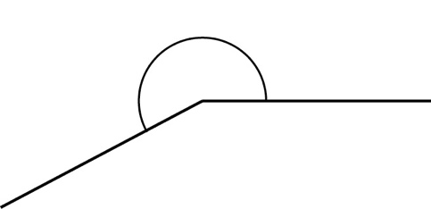

Question 13 2 marks [8.1]

Draw an angle of 176°.

Question 14 4 marks [8.2]

Use the diagram below to state:

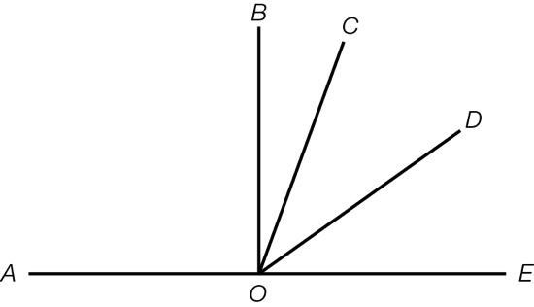

(a) name two acute angles, other than ∠*COD* ____________________

(b) a right angle ____________________

(c) an obtuse angle ____________________

Question 15 3 marks [8.3]

Find the size of the angle marked x, giving reasons.

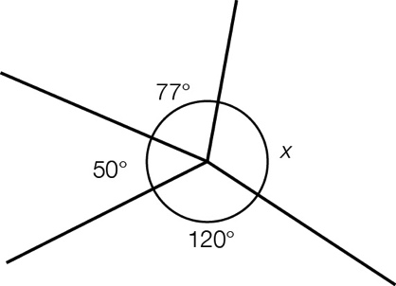

Question 16 1 marks [8.4]

On the following diagram, mark in an angle alternate to the one shown.

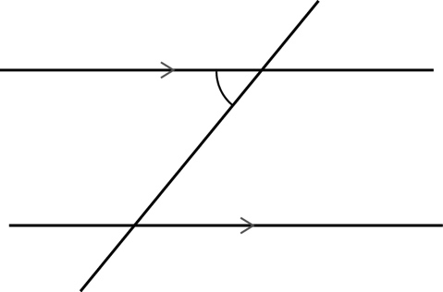

Question 17 2 marks [8.4]

Find the size of the angle marked x, giving reasons.

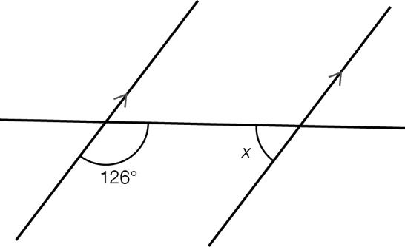

Question 18 3 marks [8.5]

Name the polygons in the pattern.

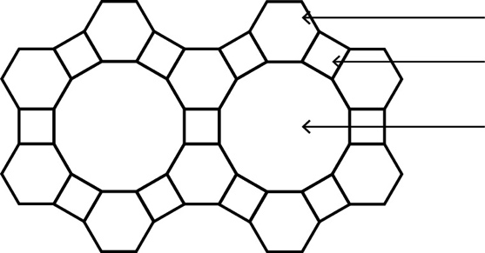

Question 19 4 marks [8.6]

Draw a diagram and then find the size of the missing angle in each of the following.

(a) A triangle with angles measuring 32° and 106°.

(b) An isosceles triangle with a non-base angle measuring 80°.

Question 20 2 marks [8.6]

Calculate the value of the exterior angle.

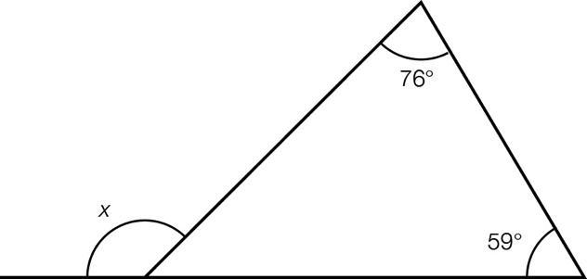

Question 21 2 marks [8.7]

Find the size of the angle marked x.

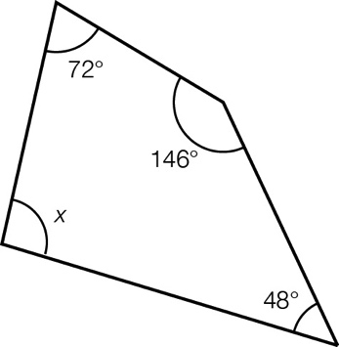

Question 22 2 marks [8.7]

A kite has a top angle measuring 124° and a bottom angle measuring 32°. Draw a diagram and find the size of the other two angles. Give reasons.

Question 23 4 marks [8.8]

Using only a compass, a ruler and a pencil, construct an angle of 120°. Leave all construction lines.

Question 24 4 marks [8.8]

Using only a compass, a ruler and a pencil, construct a pair of parallel lines.

Question 25 5 marks [8.7]

Fill in the Tree map below using all the words in the following list:

kite, parallelogram, rectangle, right trapezium, trapezium.

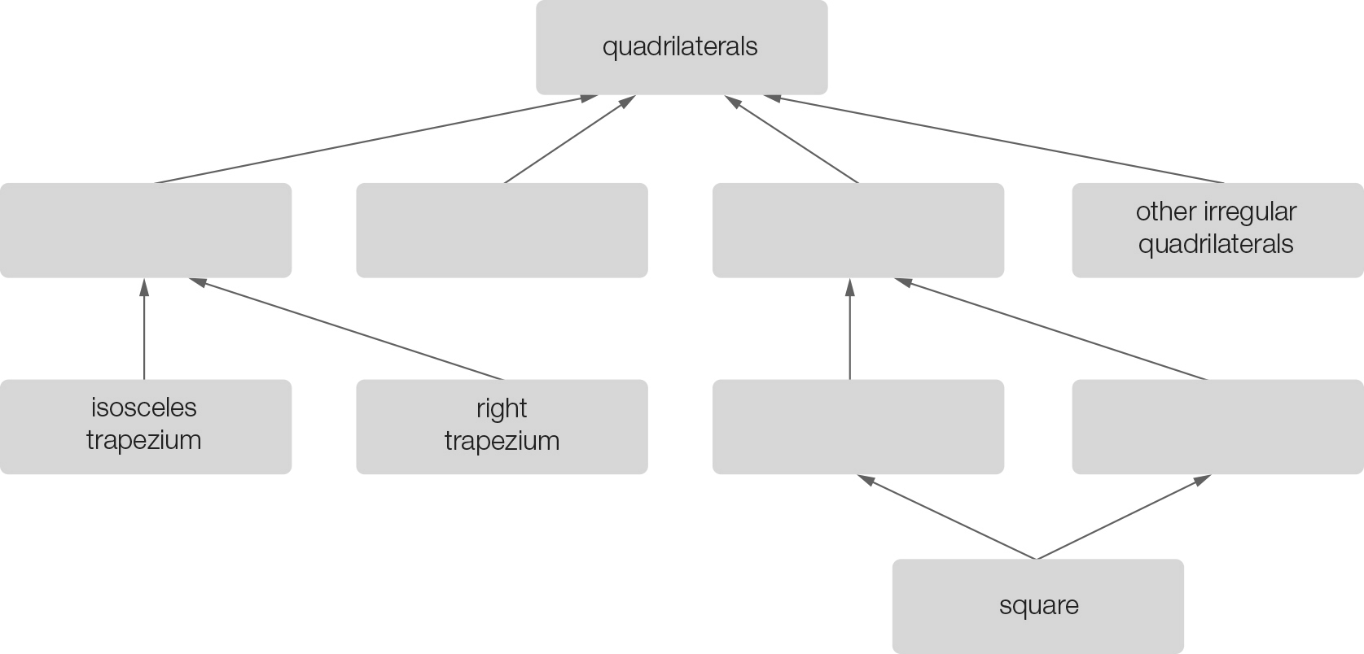

Short answer total:_______ /42

Extended answer section

Question 26 4 marks [8.3]

Find the size of the angle x, giving reasons.

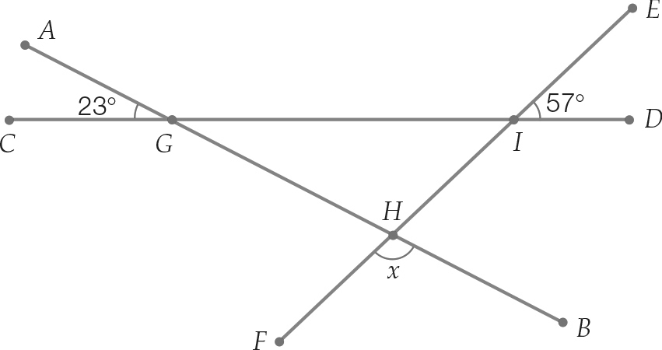

Question 27 3 marks [8.3]

Find the value of x.

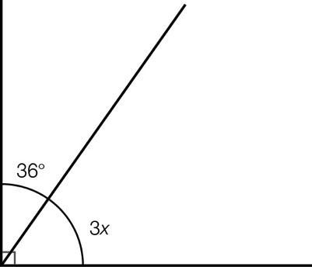

Question 28 4 marks [8.7]

Find the value of y in the diagram below.

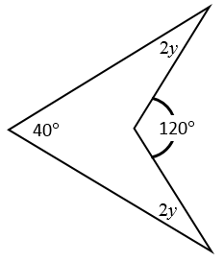

Extended answer total:_______ /11

TOTAL test marks: _______ / 63